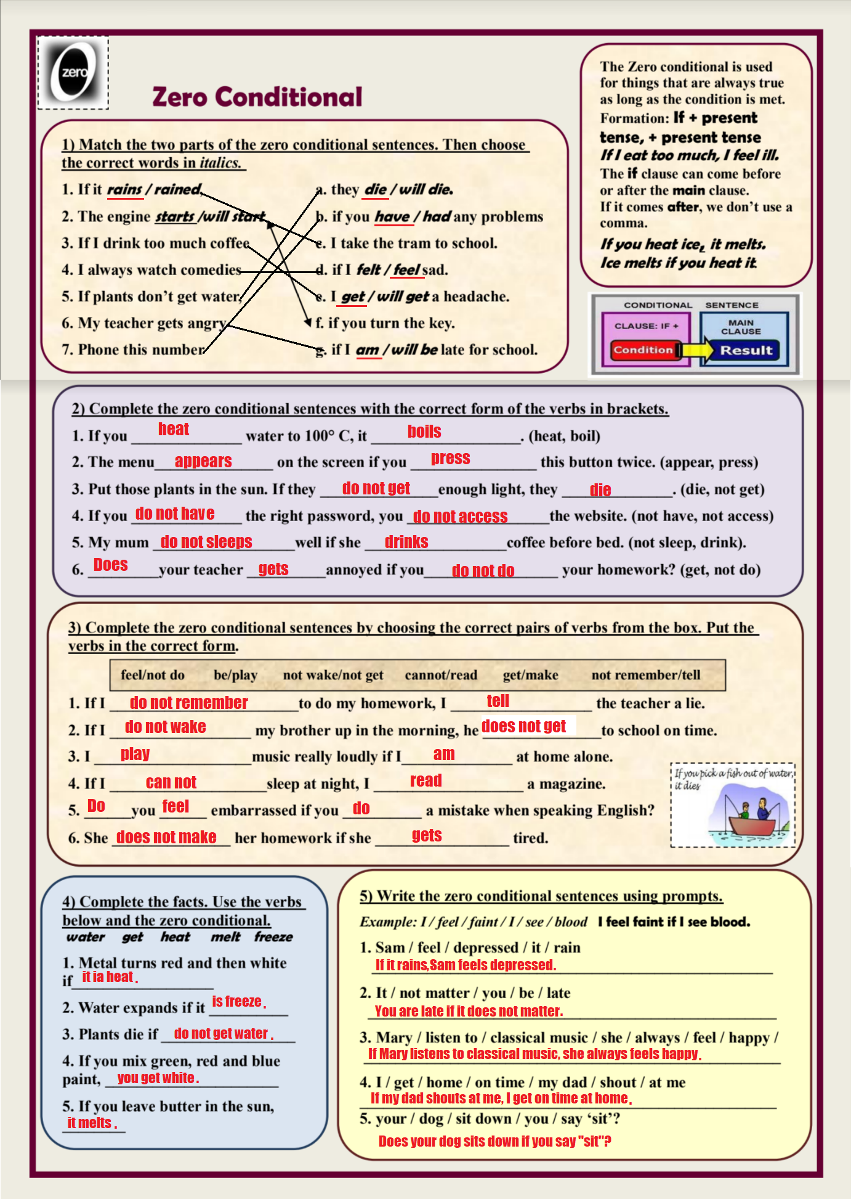**16 Question Strips**

**ZERO CONDITIONAL (with ‘if’)** ✁

∙ What happens if you don’t study for a test?

If I do not study for a test, I get an F

∙ What happens if you are late for class?

If I am late for a class, the teacher gets mad.

∙ What happens if you eat too much candy?

If I eat too much candy, my teeth hurt.

∙ What happens if you stay awake all night?

If I stay awake all the night, I am not able to get up early.

∙ What happens if you drop a glass on the floor?

If I drop a glass on the floor, my mother takes my inheritance.

∙ What happens if you don’t eat food for two days?

If I do not eat food for two days, I get weak.

∙ What happens if you talk loudly in a movie theater?

If I talk loudly in a movie theater, the people yell.

∙ What happens if you mix red and blue paint?

If I mix red and blue paint, I get another color.

∙ What happens if you add sugar to coffee?

If I add sugar to coffee, it tastes better.

∙ What happens if you throw a piece of wood into a fire?

If I throw a piece of wood into a fire, it gets on fire.

∙ What happens if you fall out of a tree?

If I fall out of a tree, I pass out.

∙ What happens if you forget your umbrella on a rainy day?

If I forget my umbrella on a rainy day, I get wet.

∙ What happens if you hit a policeman?

If I hit a policeman, I got to jail.

∙ What happens if you leave a restaurant without paying?

If I leave a restaurant without paying, the call the policeman.

∙ What happens if you lose a library book?

If I lose a library book, I pay it.

∙ What happens if you play video games for ten hours?

If I play video games for ten hours, I die.